Reports Output
Vendor transactions report
Form path
Accounts Payable → Inquiries → Vendor transactions report
This report displays all financial transactions related to vendors within a specific period
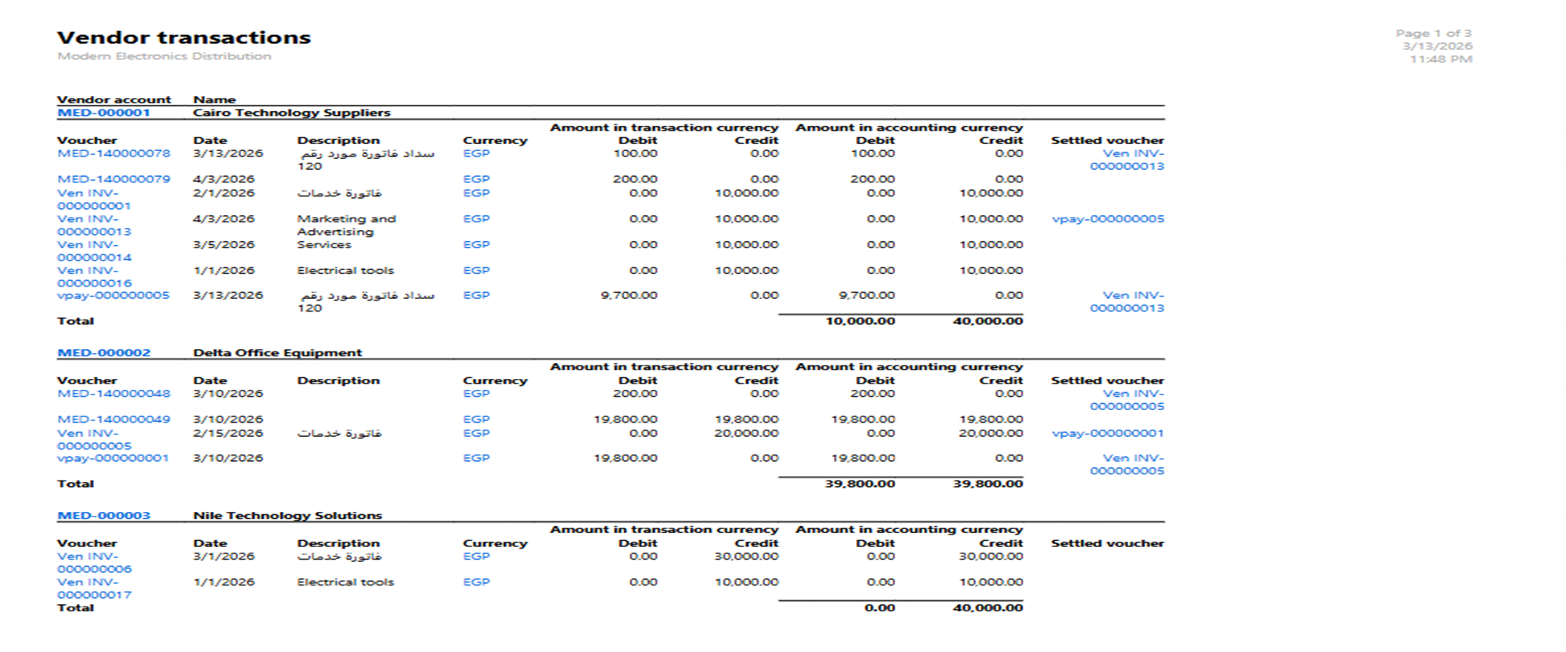
Vendor balance list
Form path
Accounts Payable → Inquiries → Vendor Balance
Description
This report shows the balance owed to each vendor.
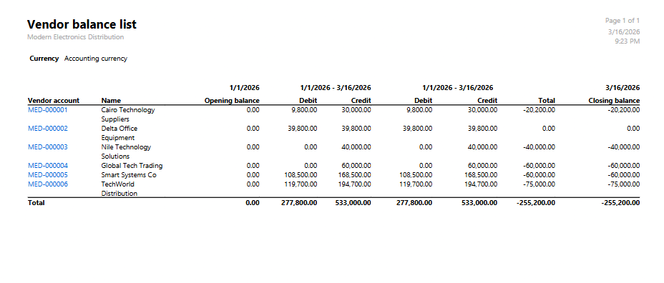
Vendor aging report
Form path
Accounts Payable → Inquiries → Vendor aging report
Description
Shows vendor balances classified based on aging periods
